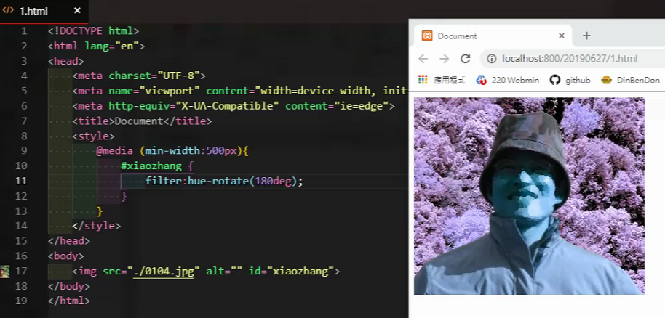

<!DOCTYPE html>

<html lang="en">

<head>

<meta charset="UTF-8">

<meta name="viewport" content="width=device-width, initial-scale=1.0">

<meta http-equiv="X-UA-Compatible" content="ie=edge">

<title>Document</title>

<style>

@media(min-width:500px){

#xiaozhang{

filter: hue-rotate(100deg);

}

}

</style>

</head>

<body>

<img src="./0104.jpg" alt="" id="xiaozhang">

</body>

</html>

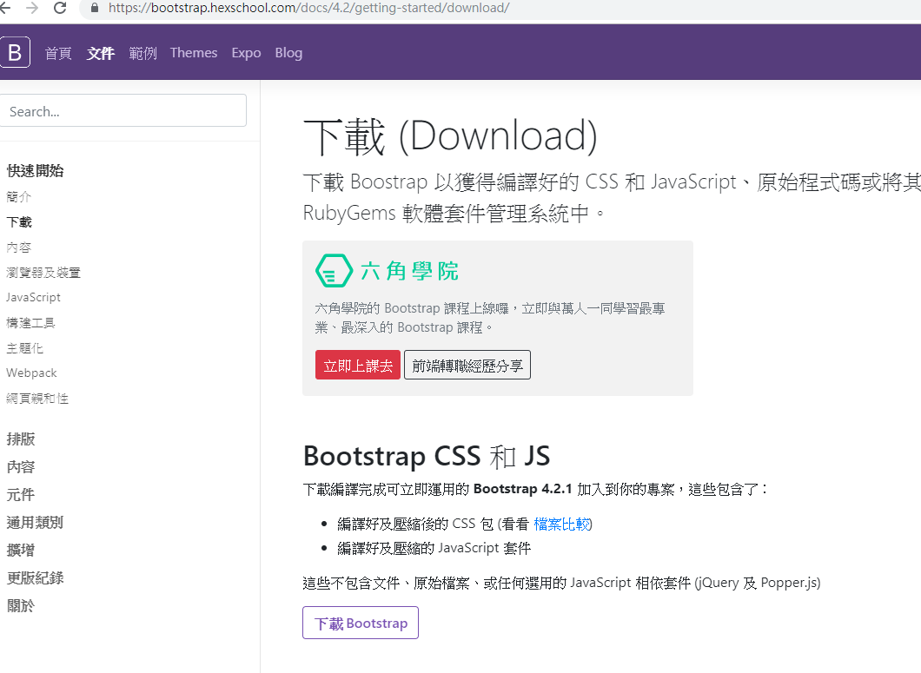

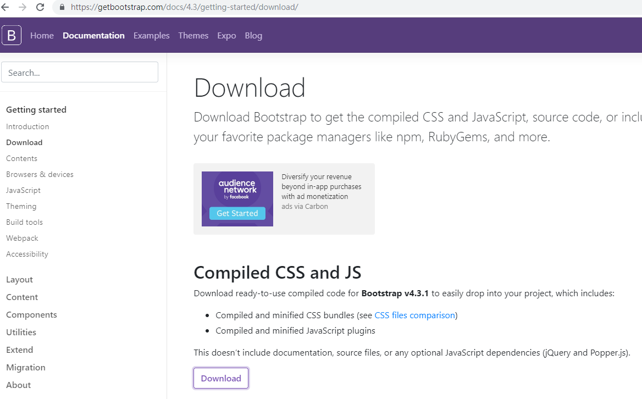

<https://bootstrap.hexschool.com/docs/4.2/getting-started/contents/>

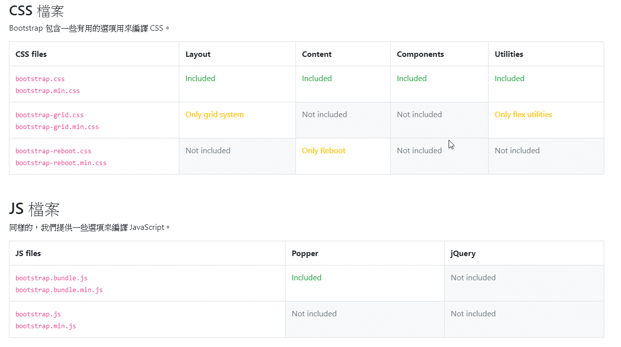

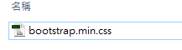

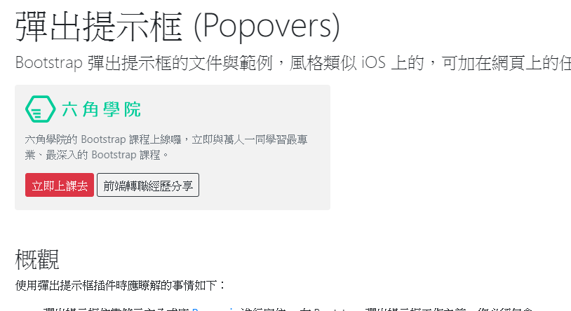

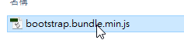

<https://fontawesome.com/download>

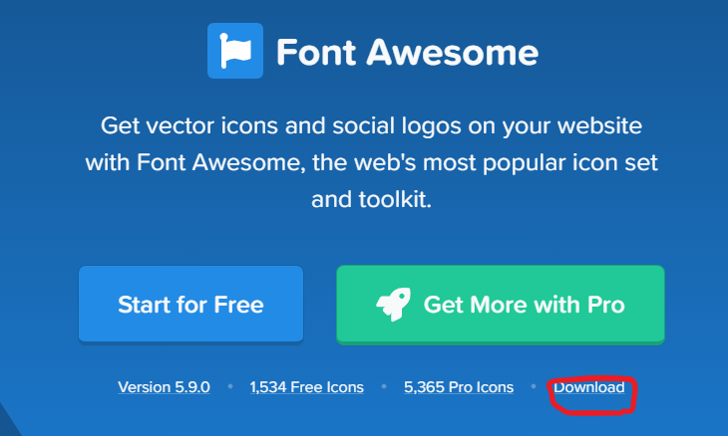

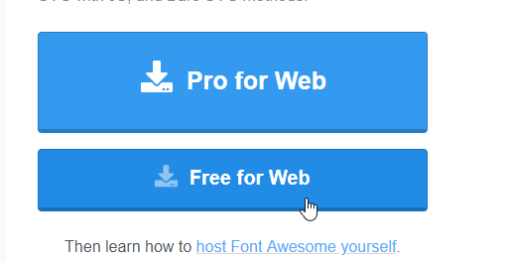

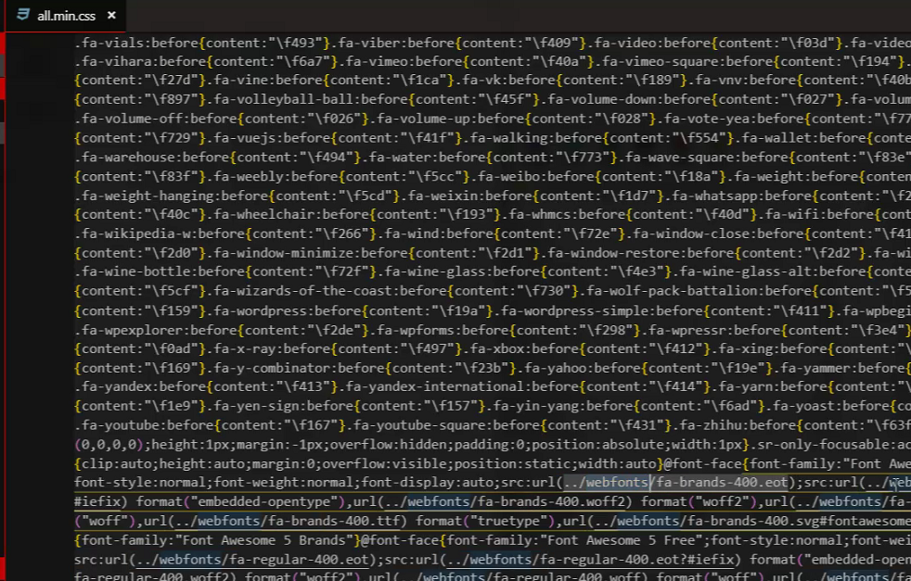

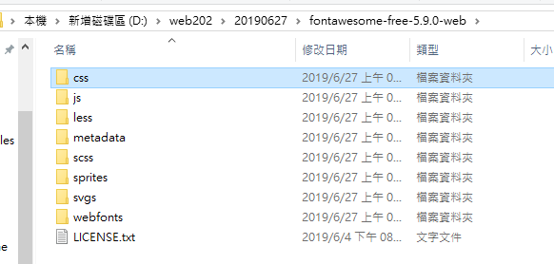

只要

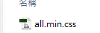 

Index.html 改語系

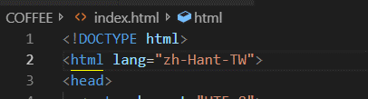

找圖做icon

<https://www.flaticon.com/>



做icon的機制

<http://tw.faviconico.org/>

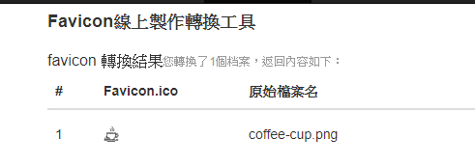

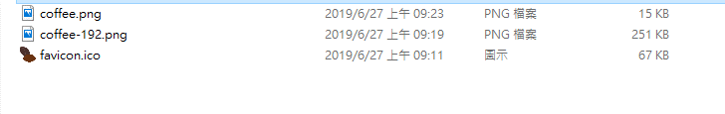

512*512 1920*1920 png

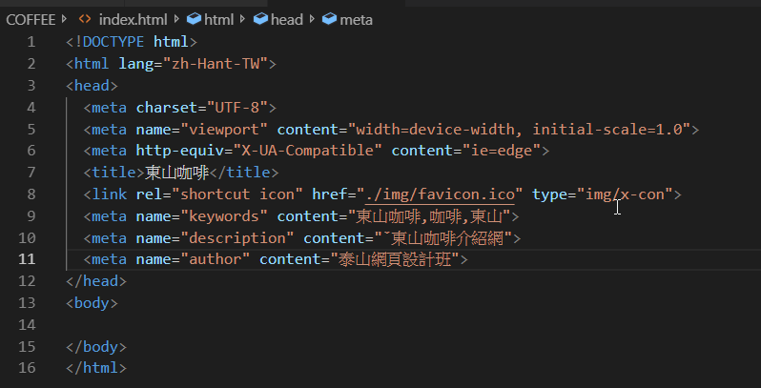

<!DOCTYPE html>

<html lang="zh-Hant-TW">

<head>

<meta charset="UTF-8">

<meta name="viewport" content="width=device-width, initial-scale=1.0">

<meta http-equiv="X-UA-Compatible" content="ie=edge">

<title>東山咖啡</title>

<link rel="shortcut icon" href="./img/favicon.ico" type="img/x-con">

<meta name="keywords" content="東山咖啡,咖啡,東山">

<meta name="description" content="ˇ東山咖啡介紹網">

<meta name="author" content="泰山網頁設計班">

</head>

<body>

</body>

</html>

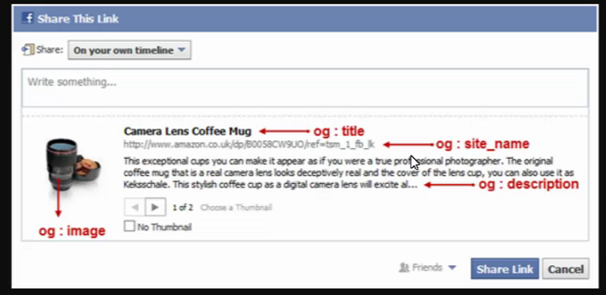

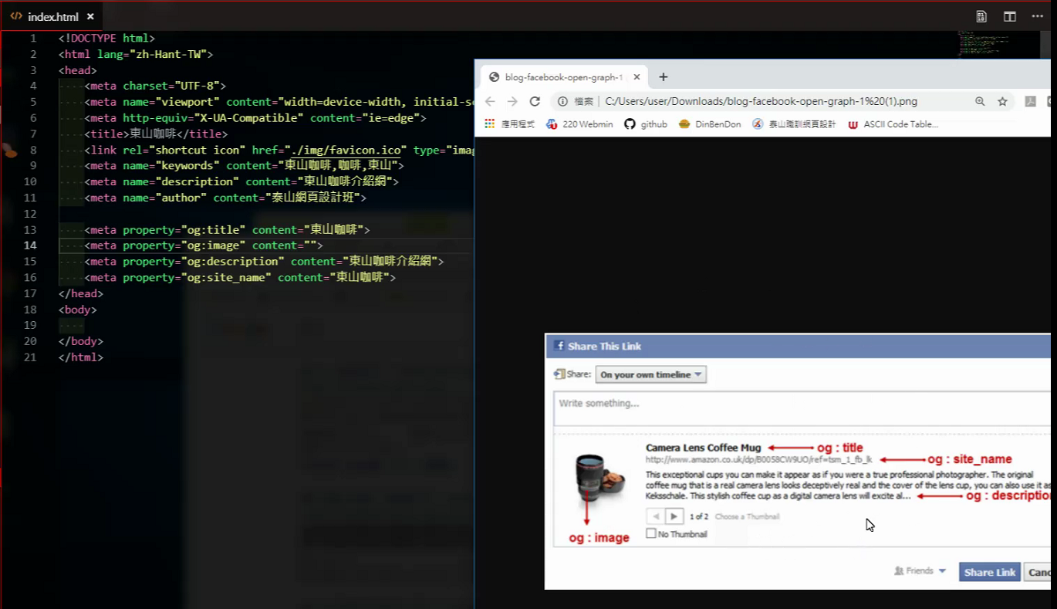

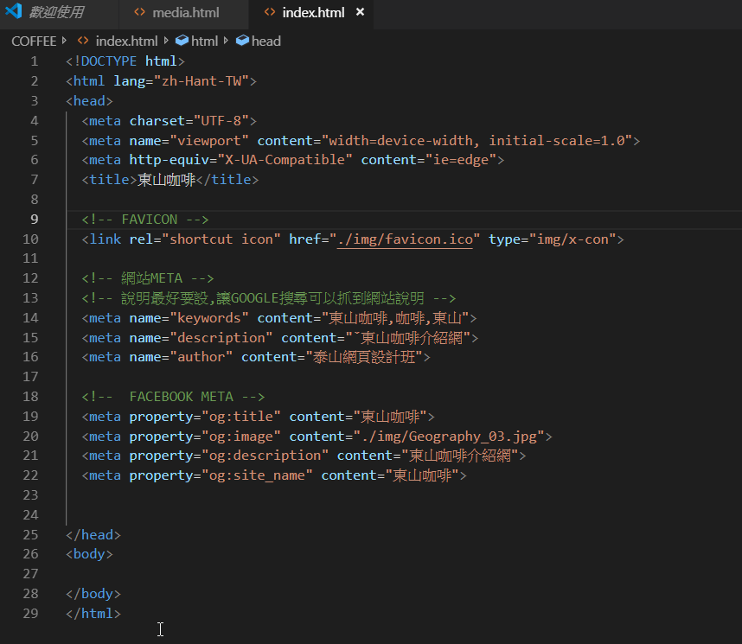

<!DOCTYPE html>

<html lang="zh-Hant-TW">

<head>

<meta charset="UTF-8">

<meta name="viewport" content="width=device-width, initial-scale=1.0">

<meta http-equiv="X-UA-Compatible" content="ie=edge">

<title>東山咖啡</title>

<!-- FAVICON -->

<link rel="shortcut icon" href="./img/favicon.ico" type="img/x-con">

<!-- 網站META -->

<!-- 說明最好要設,讓GOOGLE搜尋可以抓到網站說明 -->

<meta name="keywords" content="東山咖啡,咖啡,東山">

<meta name="description" content="ˇ東山咖啡介紹網">

<meta name="author" content="泰山網頁設計班">

<!-- FACEBOOK META -->

<meta property="og:title" content="東山咖啡">

<meta property="og:image" content="./img/Geography_03.jpg">

<meta property="og:description" content="東山咖啡介紹網">

<meta property="og:site_name" content="東山咖啡">

</head>

<body>

</body>

</html>

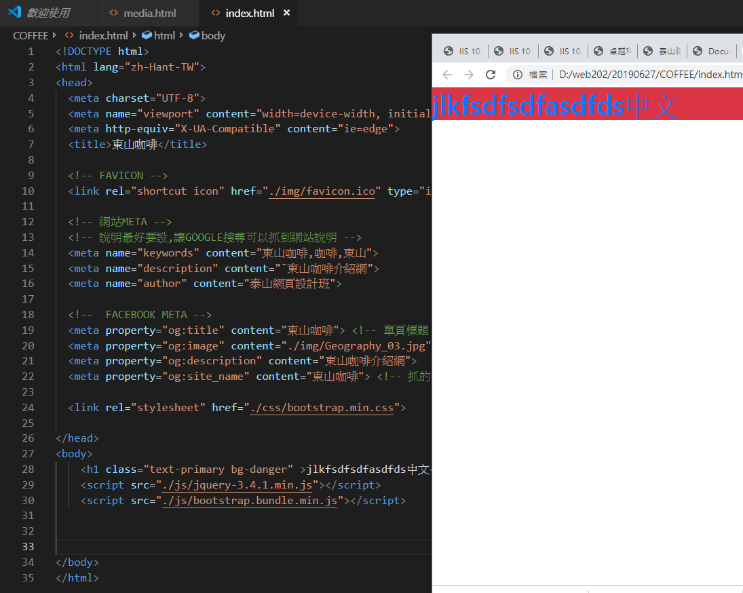

<!DOCTYPE html>

<html lang="zh-Hant-TW">

<head>

<meta charset="UTF-8">

<meta name="viewport" content="width=device-width, initial-scale=1.0">

<meta http-equiv="X-UA-Compatible" content="ie=edge">

<title>東山咖啡</title>

<!-- FAVICON -->

<link rel="shortcut icon" href="./img/favicon.ico" type="img/x-con">

<!-- 網站META -->

<!-- 說明最好要設,讓GOOGLE搜尋可以抓到網站說明 -->

<meta name="keywords" content="東山咖啡,咖啡,東山">

<meta name="description" content="ˇ東山咖啡介紹網">

<meta name="author" content="泰山網頁設計班">

<!-- FACEBOOK META -->

<meta property="og:title" content="東山咖啡"> <!-- 單頁標題 -->

<meta property="og:image" content="./img/Geography_03.jpg">

<meta property="og:description" content="東山咖啡介紹網">

<meta property="og:site_name" content="東山咖啡"> <!-- 抓的網站名稱 -->

<link rel="stylesheet" href="./css/bootstrap.min.css">

</head>

<body>

<h1 class="text-primary bg-danger" >jlkfsdfsdfasdfds中文</h1>

<script src="./js/jquery-3.4.1.min.js"></script>

<script src="./js/bootstrap.bundle.min.js"></script>

</body>

</html>

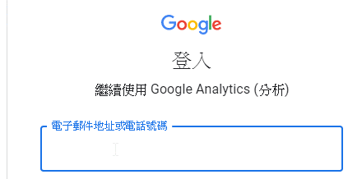

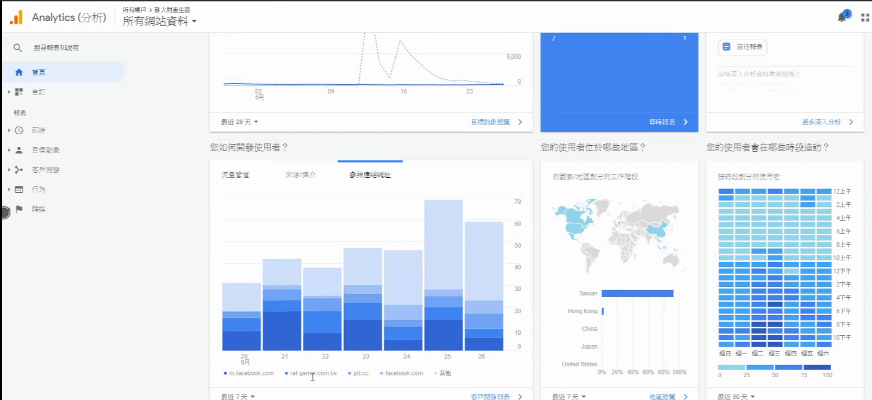

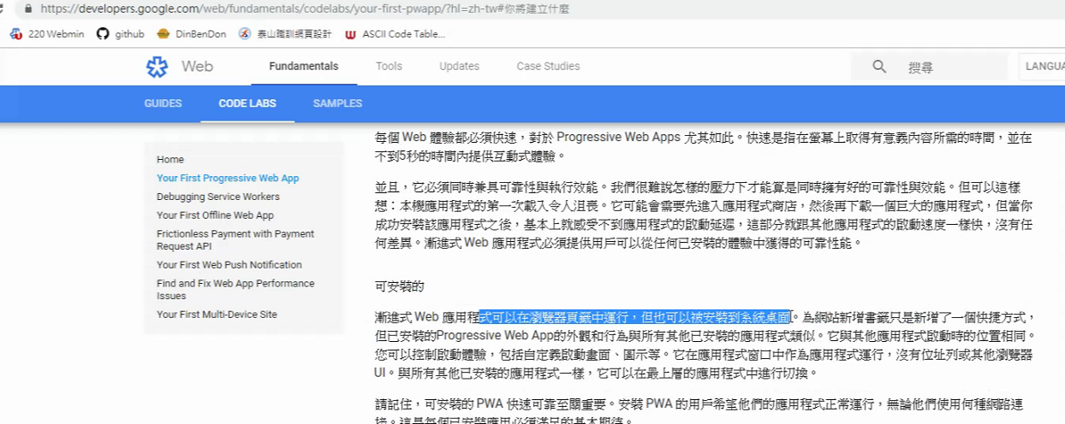

<https://developers.google.com/web/progressive-web-apps/>

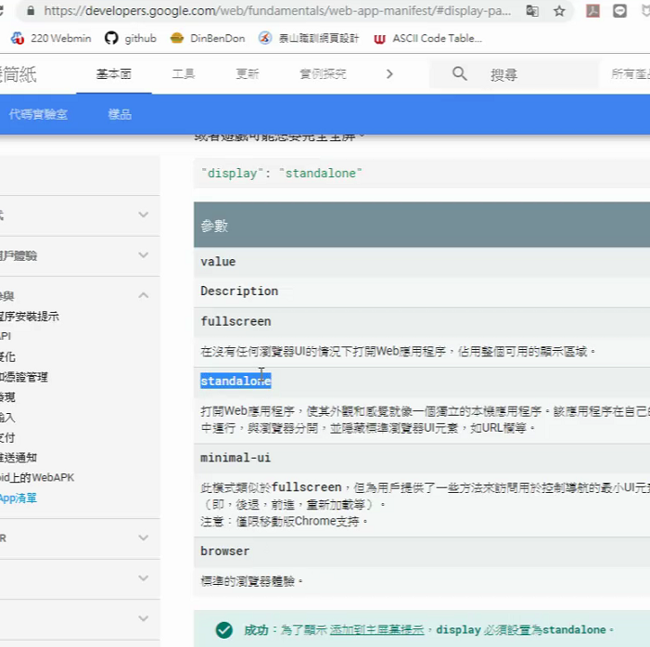

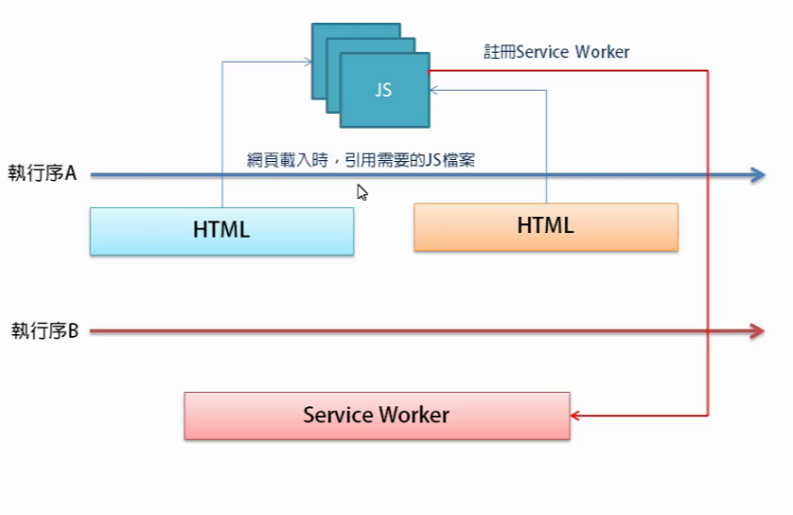

<https://developers.google.com/web/fundamentals/codelabs/your-first-pwapp/#%E5%BB%BA%E7%AB%8B_web_%E6%87%89%E7%94%A8%E7%A8%8B%E5%BC%8F%E8%B3%87%E8%A8%8A%E6%B8%85%E5%96%AE>

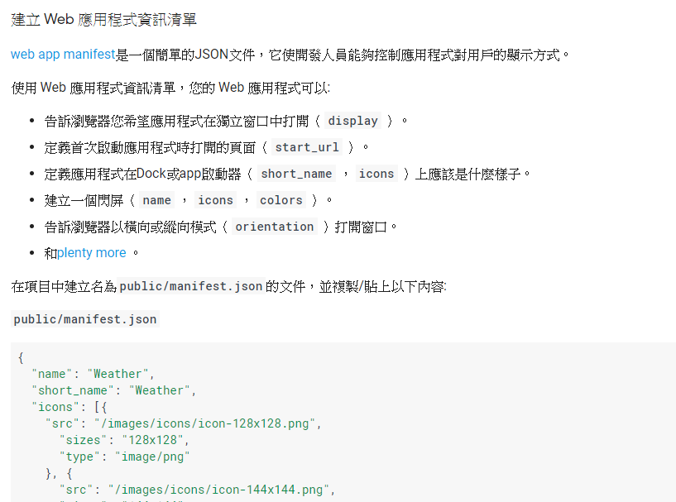

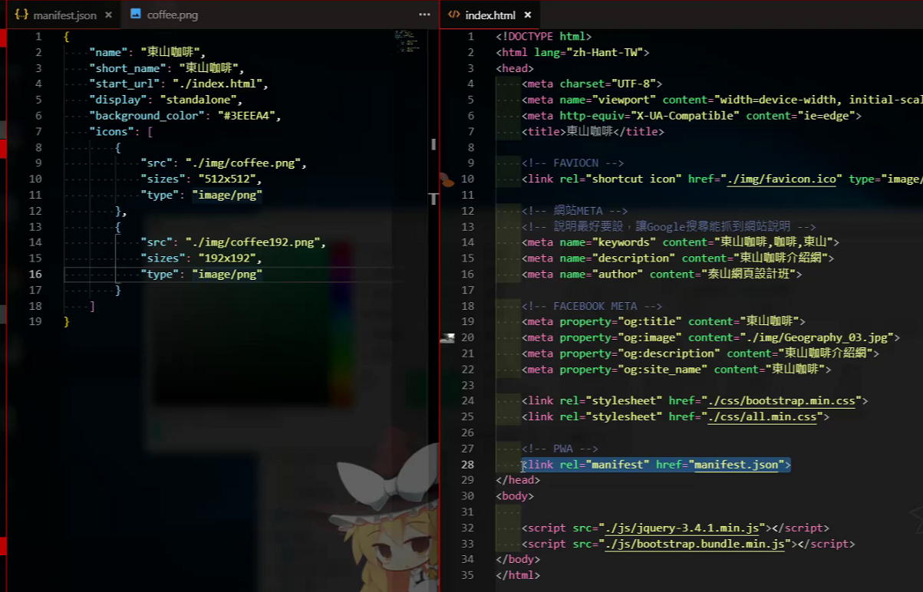

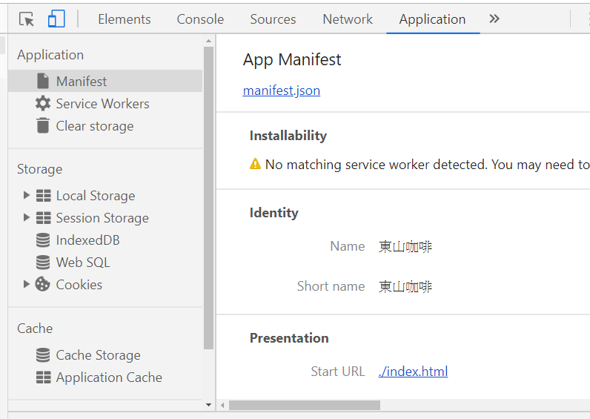

<https://bootstrap.hexschool.com/docs/4.2/layout/overview/>

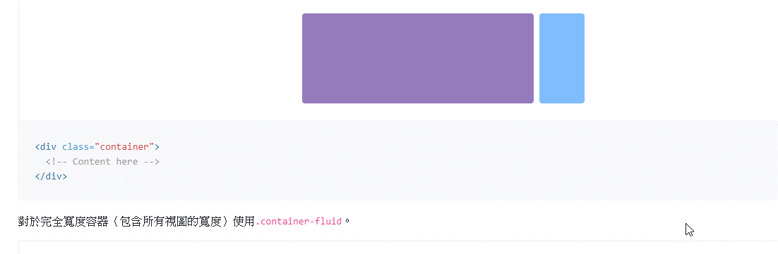

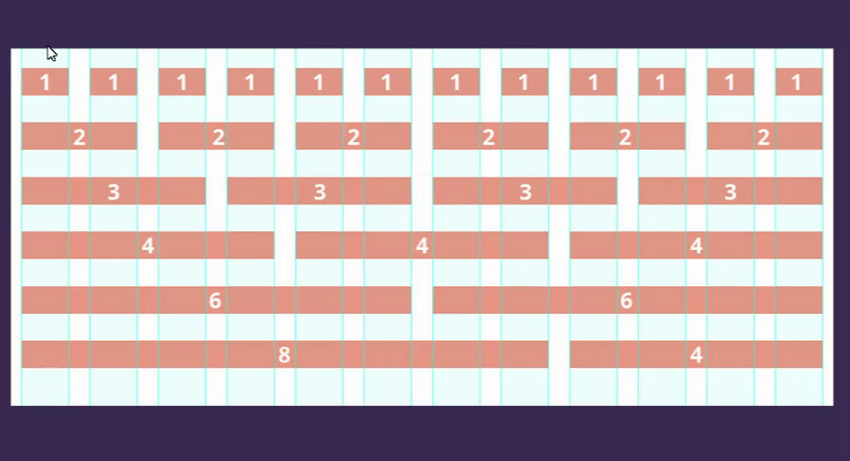

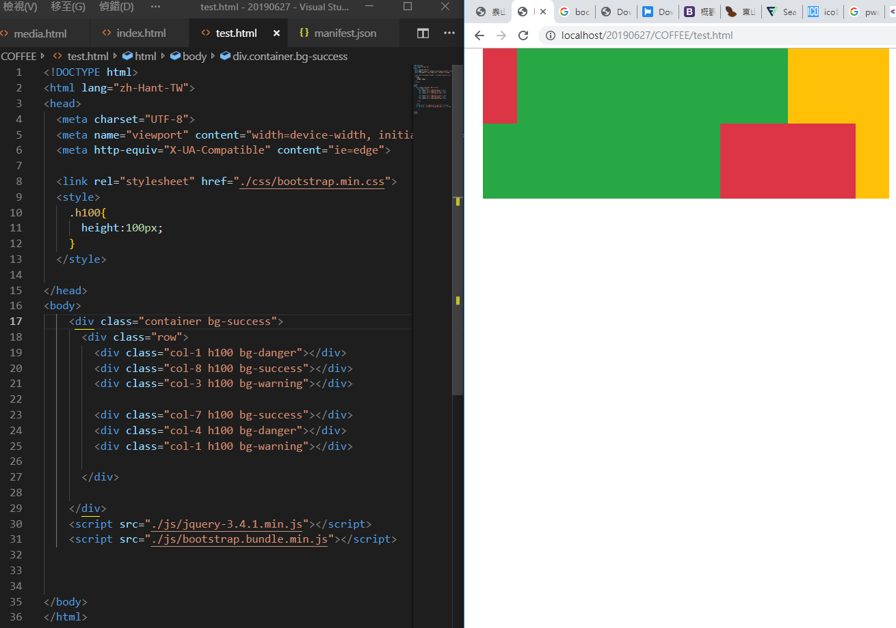

網格系統

<!DOCTYPE html>

<html lang="zh-Hant-TW">

<head>

<meta charset="UTF-8">

<meta name="viewport" content="width=device-width, initial-scale=1.0">

<meta http-equiv="X-UA-Compatible" content="ie=edge">

<link rel="stylesheet" href="./css/bootstrap.min.css">

<style>

.h100{

height:100px;

}

</style>

</head>

<body>

<div class="container bg-success">

<div class="row">

<div class="col-1 h100 bg-danger"></div>

<div class="col-8 h100 bg-success"></div>

<div class="col-3 h100 bg-warning"></div>

<div class="col-7 h100 bg-success"></div>

<div class="col-4 h100 bg-danger"></div>

<div class="col-1 h100 bg-warning"></div>

</div>

</div>

<script src="./js/jquery-3.4.1.min.js"></script>

<script src="./js/bootstrap.bundle.min.js"></script>

</body>

</html>

只要調整高度,

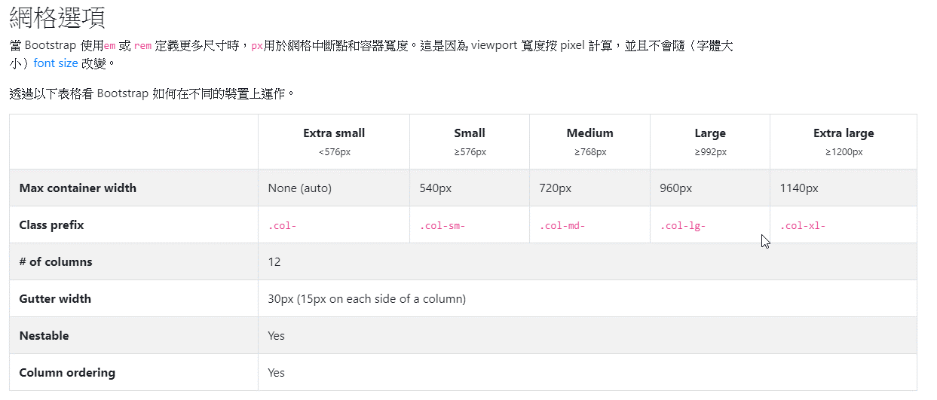

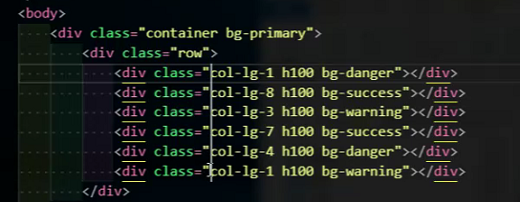

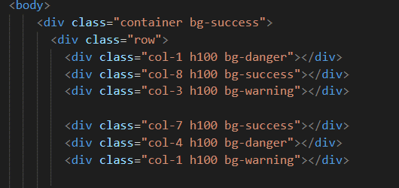

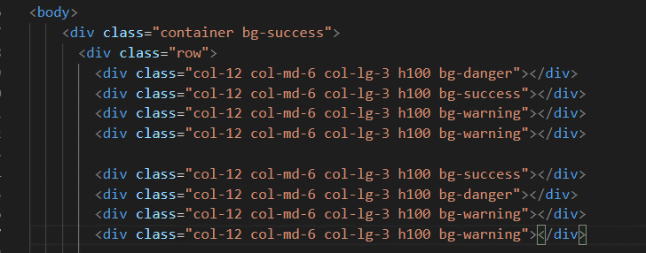

<https://bootstrap.hexschool.com/docs/4.2/layout/grid/>

<https://bootstrap.hexschool.com/docs/4.2/components/navbar/>

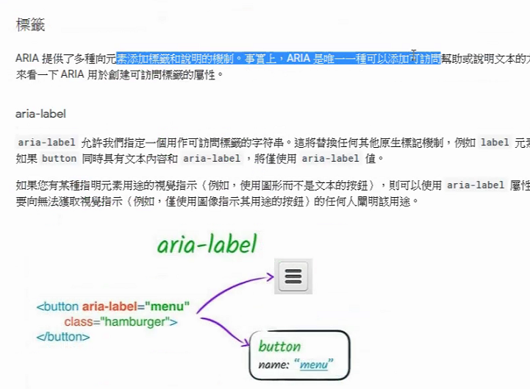

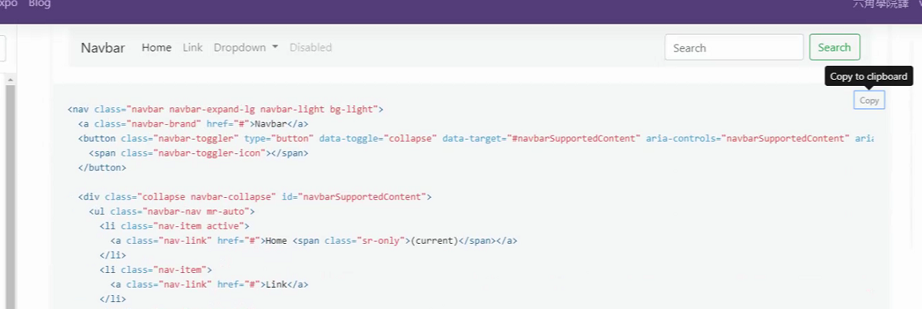

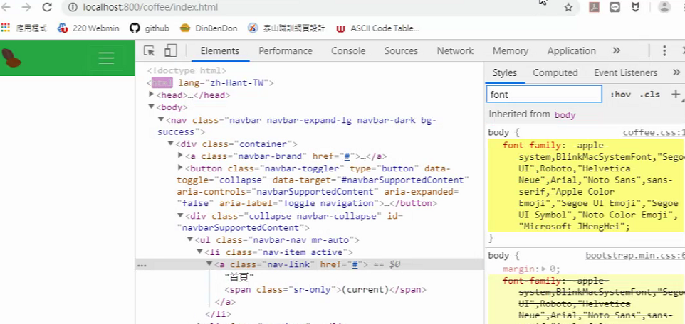

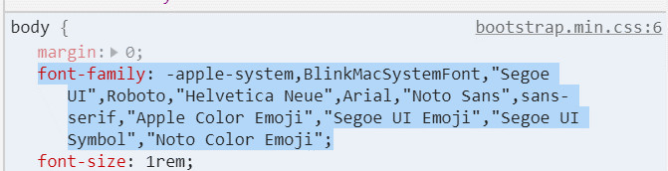

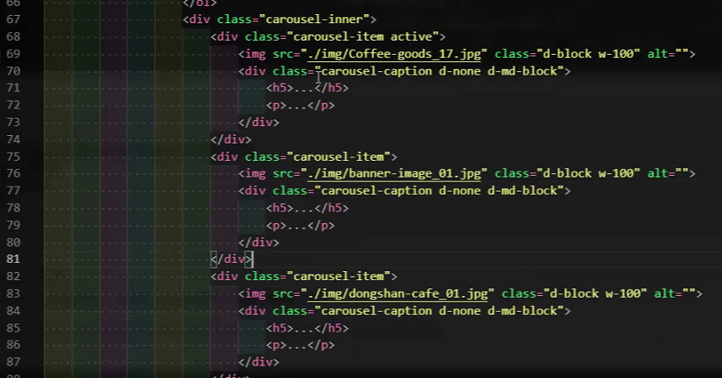

導覽或是圖片輪播都要外面包一個

<div class="container">

</div>

<!DOCTYPE html>

<html lang="zh-Hant-TW">

<head>

<meta charset="UTF-8">

<meta name="viewport" content="width=device-width, initial-scale=1.0">

<meta http-equiv="X-UA-Compatible" content="ie=edge">

<title>東山咖啡</title>

<!-- FAVICON -->

<link rel="shortcut icon" href="./img/favicon.ico" type="img/x-con">

<!-- 網站META -->

<!-- 說明最好要設,讓GOOGLE搜尋可以抓到網站說明 -->

<meta name="keywords" content="東山咖啡,咖啡,東山">

<meta name="description" content="ˇ東山咖啡介紹網">

<meta name="author" content="泰山網頁設計班">

<!-- FACEBOOK META -->

<meta property="og:title" content="東山咖啡"> <!-- 單頁標題 -->

<meta property="og:image" content="./img/Geography_03.jpg">

<meta property="og:description" content="東山咖啡介紹網">

<meta property="og:site_name" content="東山咖啡"> <!-- 抓的網站名稱 -->

<link rel="stylesheet" href="./css/bootstrap.min.css">

<link rel="stylesheet" href="./css/all.min.css">

<link rel="stylesheet" href="./css/coffee.css">

<!-- PWA -->

<link rel="manifest" href="manifest.json">

</head>

<body>

<!-- <h1 class="text-primary bg-danger" >jlkfsdfsdfasdfds中文</h1> -->

<nav class="navbar navbar-expand-lg navbar-light bg-success">

<div class="container ">

<a class="navbar-brand" href="#">

<img src="./img/favicon.ico" alt="" width="30" height="30" class=" d-inline-block align-top"></a>

<button class="navbar-toggler" type="button" data-toggle="collapse" data-target="#navbarNavDropdown"

aria-controls="navbarNavDropdown" aria-expanded="false" aria-label="Toggle navigation">

<span class="navbar-toggler-icon"></span>

</button>

<div class="collapse navbar-collapse " id="navbarSupportedContent">

<ul class="navbar-nav mr-auto ">

<li class="nav-item active">

<a class="nav-link text-white" href="#">首頁 <span class="sr-only">(current)</span></a>

</li>

<li class="nav-item">

<a class="nav-link text-white" href="#">景點介紹</a>

</li>

<li class="nav-item">

<a class="nav-link text-white" href="#">商品介紹</a>

</li>

</ul>

</div>

</div>

</nav>

<div class="container"> <!-- -->

<div id="carouselExampleIndicators" class="carousel slide" data-ride="carousel">

<ol class="carousel-indicators">

<li data-target="#carouselExampleIndicators" data-slide-to="0" class="active"></li>

<li data-target="#carouselExampleIndicators" data-slide-to="1"></li>

<li data-target="#carouselExampleIndicators" data-slide-to="2"></li>

</ol>

<div class="carousel-inner">

<div class="carousel-item active">

<img src="./img/banner-image_12.jpg" class="d-block w-100" alt="...">

<div class="carousel-caption d-none d-md-block">

<h5>木村園東山台灣咖啡</h5>

<p>杯杯非賣品</p>

</div>

</div>

<div class="carousel-item">

<img src="./img/banner-image_13.jpg" class="d-block w-100" alt="...">

<div class="carousel-caption d-none d-md-block">

<h5>咖啡豆</h5>

<p>百分百無農藥種植有機咖啡豆</p>

</div>

</div>

<div class="carousel-item">

<img src="./img/banner-image_14.jpg" class="d-block w-100" alt="...">

<div class="carousel-caption d-none d-md-block">

<h5>東山農會咖啡文化館</h5>

<p>認識東山咖啡文化</p>

</div>

</div>

</div>

<a class="carousel-control-prev" href="#carouselExampleIndicators" role="button" data-slide="prev">

<span class="carousel-control-prev-icon" aria-hidden="true"></span>

<span class="sr-only">Previous</span>

</a>

<a class="carousel-control-next" href="#carouselExampleIndicators" role="button" data-slide="next">

<span class="carousel-control-next-icon" aria-hidden="true"></span>

<span class="sr-only">Next</span>

</a>

</div>

</div>

<script src="./js/jquery-3.4.1.min.js"></script>

<script src="./js/bootstrap.bundle.min.js"></script>

</body>

</html>

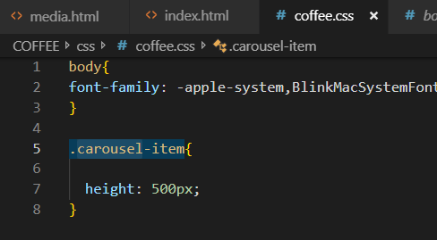

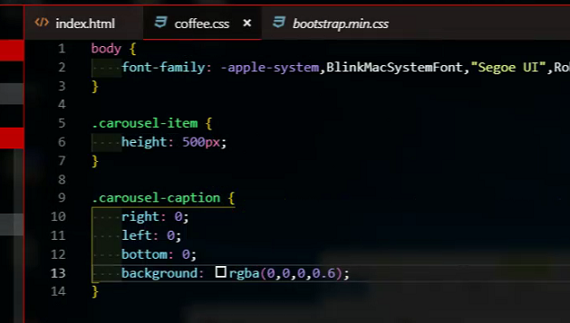

<https://fontawesome.com/icons?d=gallery&q=tree>

